## 2.3.1 game list

### 2.3.1.1 Purpose

* This is a landing page for the app, a place where the user starts.
* The user can navigate through all current listed games in the meta manager database
* User is able to quickly navigate through a list of games.
* This is the landing page for the app, so the user starts here. ( aka home screen)
* The user can go to a specific games build list page or navigate the menu: fav games, search, about screens  
  2.3.1.2 Wireframe Screenshot  
  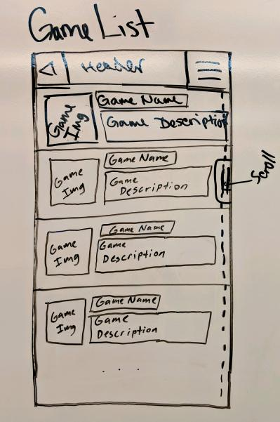  
  2.3.1.3 Mockup Screenshot  
  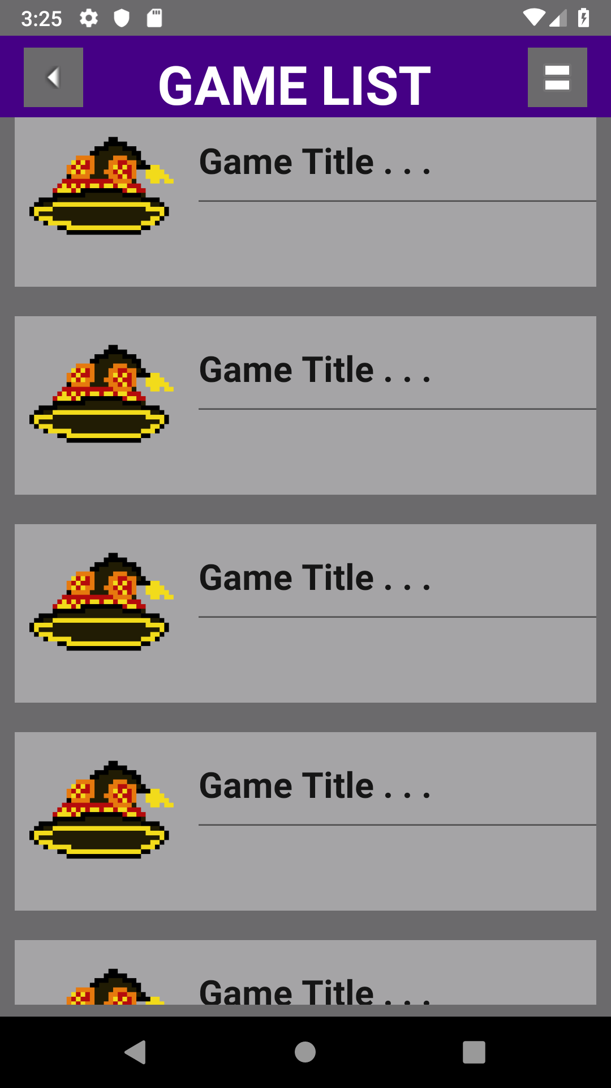

### 2.3.1.4 Prototype Screenshot Screenshot of prototype for this interface goes here.

### 2.3.1.5 Design Commentary

Talk about how your UI changed as it went through the steps of Wireframe -> Mockup -> Prototype. What did you like / dislike at each stage that influenced the next round of UI development?